Quad-copter Safety Tether Design

This document explains how the safety tether was made for the DVZ project in Spring, 2015. This tether has proven to effectively keep the quad’s altitude constrained so it cannot crash into the ceiling. The tether was intended to be used during initial autonomous flights in the Engineering center while the system is not fully trusted yet. The tether is shown below keeping the quad from flying any higher than it currently is.

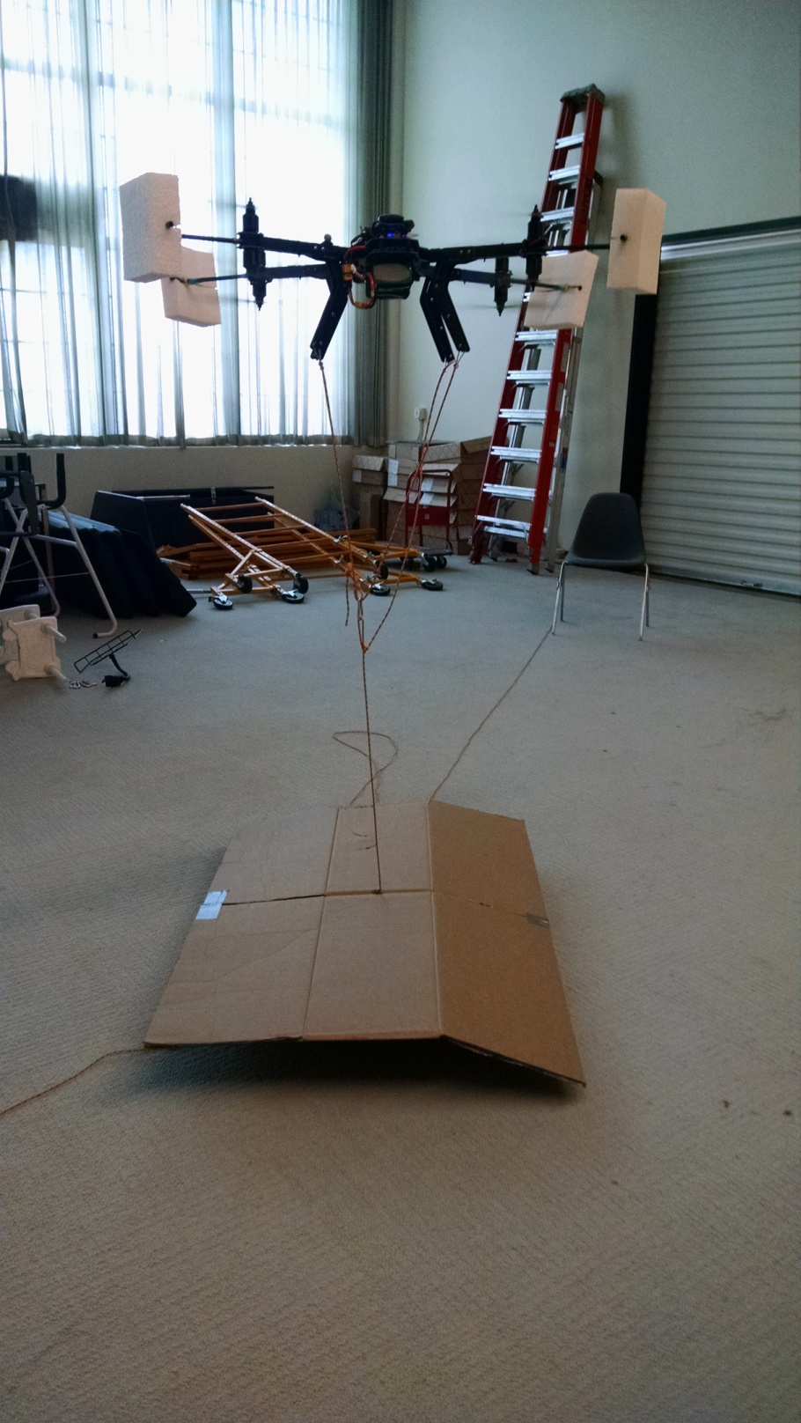

# Design Overview:

The tether worked like this: Tie the quad to a furniture dolly on the ground that weighs too much for the quad to lift. A furniture dolly was used so that it could be pulled back and forth to stay under the quad as it navigated through the hallway. Pieces of plywood were duct taped to the dolly to add weight and provide a central place to attach the string, since the dolly only has a wooden outline with wheels at the corners. The plywood pieces both had holes drilled in the middle for the string to pass through. The string was knotted below the very bottom piece of plywood so that it couldn’t pull through.

The cardboard was placed on top of the dolly to act as a landing pad. This was just for temporary use and should be replaced with particle board or something more firm.

The string used was 550 paracord because it is light, strong, and easy to tie knots in. It was both to constrain the quad and to pull the cart back and forth by having a separate string coming out of each side of the dolly. The string was attached to the quad using 4 metal clips connecting the sting to the standoffs on the bottom of each quad leg. The sting was tied so that it could pass through all the legs and connect to a central carabiner in a way that would equalize tension to the legs. This would require pulleys to be used instead of metal clips if equalizing was necessary.

# Current State:

Currently the furniture dolly is gone because it has been returned to the aerospace machine shop where it was borrowed from. All other hardware except string to pull the cart around should be with the other DVZ hardware.